

CSA0501-DATABASE MANAGEMENT SYSTEMS

LAB EXPERIMENTS DATE: 16/07/2026

EXPERIMENT 6 – SELECT with BETWEEN, IN and Aggregate Functions

AIM: To view the records from the Pet Management System database using SELECT commands with BETWEEN, IN, and Aggregate Functions.
PROCEDURE:

Open MySQL and select the pet_management database.

Ensure the pet_details table contains records.

Execute queries using the BETWEEN operator.

Execute queries using the IN operator.

Use aggregate functions like AVG, MAX, MIN, SUM, and COUNT.

Verify the outputs and record the results.

PROGRAM:

1. Display all records:

USE pet_management;

SELECT * FROM pet_details;

OUTPUT:

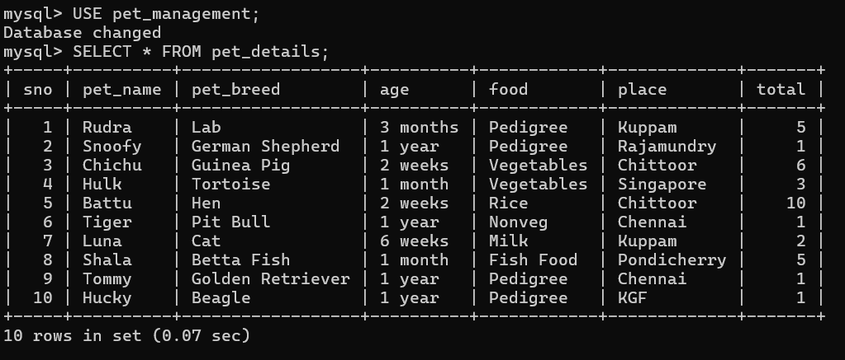

2. IN Operator
Display pets from Chennai and Kuppam
SELECT * FROM pet_details
WHERE place IN ('Chennai','Kuppam');
OUTPUT:

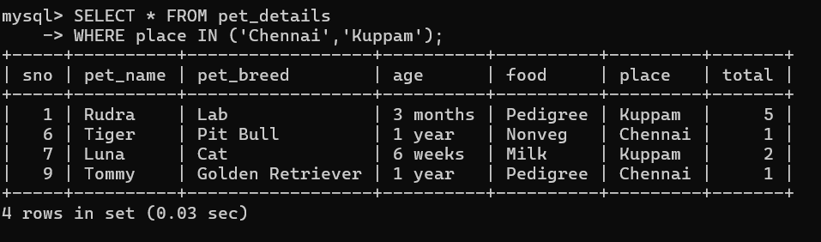

3. BETWEEN Operator
Display pets whose total is between 2 and 6
SELECT * FROM pet_details
WHERE total BETWEEN 2 AND 6;
OUTPUT:

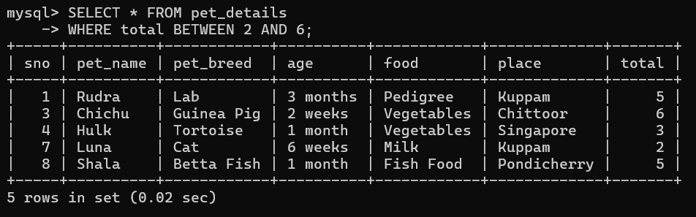
4. Aggregate Function – AVG
Find the average total number of pets
SELECT AVG(total) AS Average_Total
FROM pet_details;
OUTPUT:

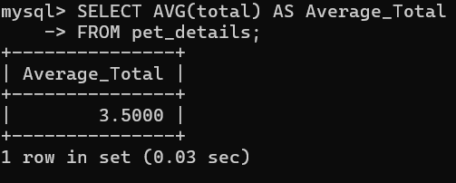

5. Aggregate Function – MAX and MIN
Find the maximum and minimum total

SELECT MAX(total) AS Maximum_Total,
MIN(total) AS Minimum_Total
FROM pet_details;
OUTPUT:

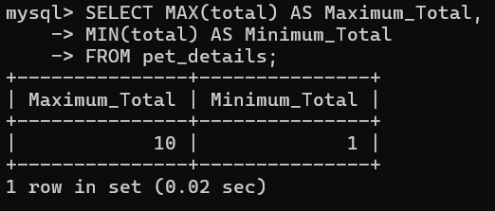
6. Aggregate Function – MAX, MIN, AVG (Group By Place)
SELECT place,
MAX(total) AS Maximum,
MIN(total) AS Minimum,
AVG(total) AS Average
FROM pet_details
GROUP BY place;
OUTPUT:
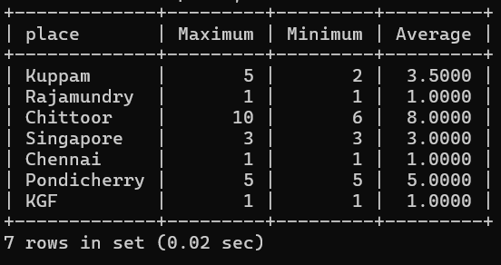
7. Aggregate Function – Food and Average Total
SELECT food,
AVG(total) AS Average_Total
FROM pet_details
GROUP BY food;
OUTPUT:
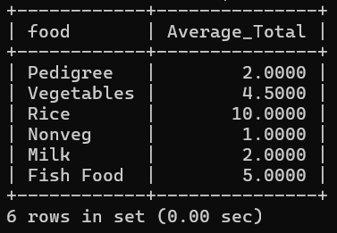
8. Aggregate Function – SUM
SELECT SUM(total) AS Total_Pets
FROM pet_details;
OUTPUT:
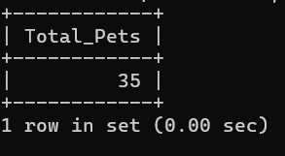

9. Aggregate Function – COUNT
Count the number of pets in each place
SELECT place,
COUNT(*) AS Number_of_Pets
FROM pet_details
GROUP BY place;

OUTPUT:
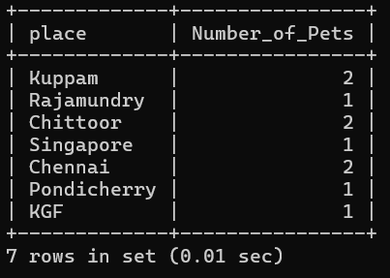
10. Aggregate Function – COUNT
Count the number of pets based on food type
SELECT food,
COUNT(*) AS Number_of_Pets
FROM pet_details
GROUP BY food;
OUTPUT:
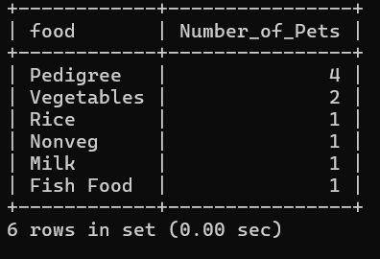

RESULT: The SELECT statements using BETWEEN, IN, and Aggregate Functions were executed successfully. The required records and summary values were displayed correctly.

